CSE 581

**Lab 12: Stored Procedures**

*Do this against YOUR own database.*

***For the entire lab, provide all of your SQL as text, inserted at the beginning of the document.***

***For each step also provide a screenshot of execution, showing the SQL and the results.***

***Please make sure both the SQL and the screenshots are marked w/ the question number that they are answering.***

CREATE PROCEDURE dbo.MyFunction(@facultyId AS VARCHAR(20), @studentId AS VARCHAR(20),

@courseId AS INT, @courseGrade AS FLOAT)

AS

IF NOT EXISTS(SELECT 1 FROM Users WHERE NTID = @facultyId)

BEGIN

PRINT 'Error: You are not allowed to assign grades for this course'

END

ELSE IF NOT EXISTS(SELECT 1 FROM CourseEnrollment ce WHERE ce.StudentId = @studentId)

BEGIN

PRINT 'Error: The Student is not taking the course you specified'

END

ELSE IF EXISTS (SELECT ce.FinalGrade FROM CourseEnrollment ce WHERE ce.StudentId = @studentId AND CourseId = @courseId)

BEGIN

DECLARE @oldGrade FLOAT

SET @oldGrade = (SELECT ce.FinalGrade FROM courseEnrollment ce WHERE ce.StudentId = @studentId AND CourseId = @courseId)

UPDATE CourseEnrollment

SET FinalGrade = @courseGrade

WHERE StudentId = @studentId

AND CourseId = @courseId

PRINT 'Success, with a warning - Student’s existing grade ' + CAST(@oldGrade AS VARCHAR) + ' was changed

to ' + CAST(@courseGrade AS VARCHAR)

END

ELSE

BEGIN

PRINT 'Success'

UPDATE CourseEnrollment

SET FinalGrade = @courseGrade

WHERE StudentId = @studentId

AND CourseId = @courseId

END;

1. Run the stored procedure to prove[1] that all 4 cases work[2].

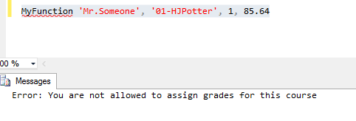

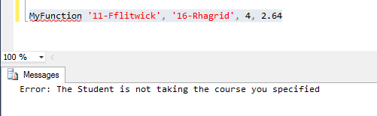

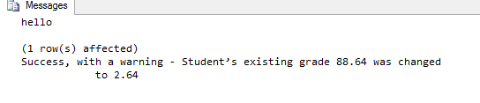

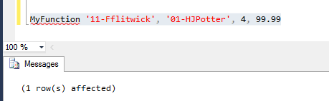

1. Create a SP that will return back 2 joined tables. I’ll leave which tables and which join type up to you.

1. You have to prove to me that it works exactly as expected. That means you need to prove that the right messages were printed, and that the data was or was not changed, depending on the case. The only way you can prove this to me is via screenshots.
2. If you need to modify the data in order to be able to execute all of the cases, feel free to do so. I do not need to see these, just make sure that the data prior to the SP’s execution is showing the valid input.